**AIPP LAB 1**

**Name: MAHVISH ISAQ**

**Hall Ticket No.: 2503B05134**

**Date: 27/10/2025 (Week 1)**

**______________________________________________**

**Task 1:**

**Install and configure GitHub Copilot in VS Code.**

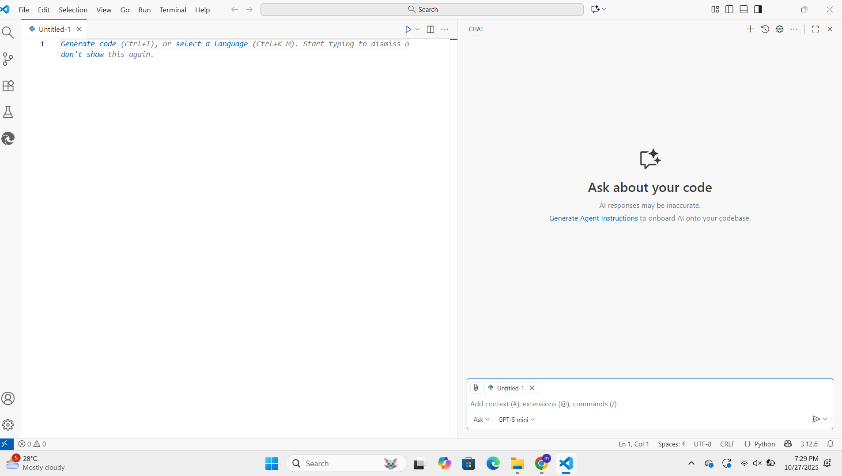

**Task 2:**

**USE COPILOT TO GENERATE is_prime() PYTHON FUNCTION.**

***PROMPTS:***

**1) Use Copilot to generate is_prime() python function.**

**2) Update code so that input can be entered by the User.**

**3) I need to enter at least 5 times the loop so update code.**

***CODE:***

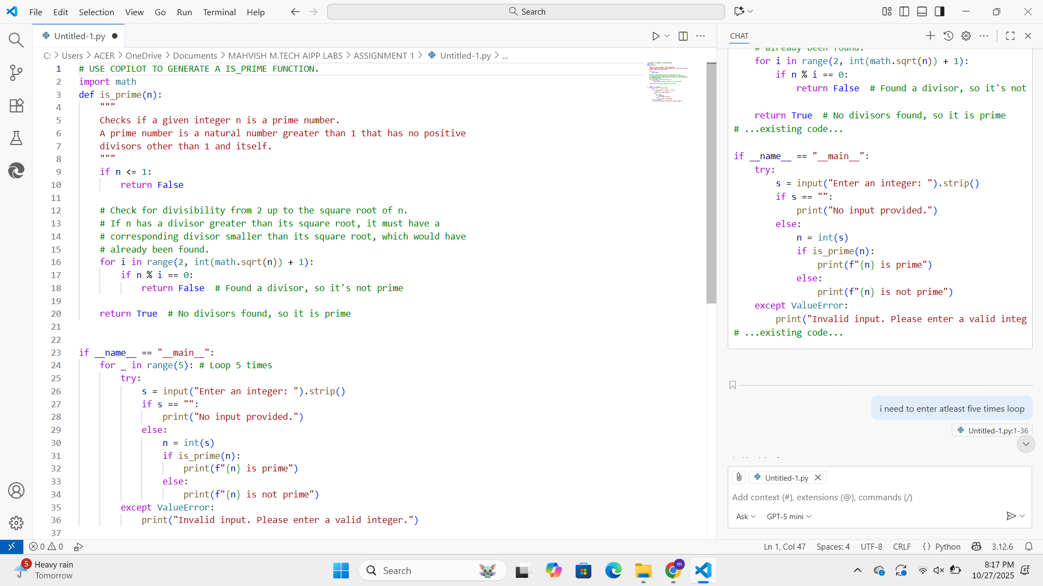

***OUTPUT:***

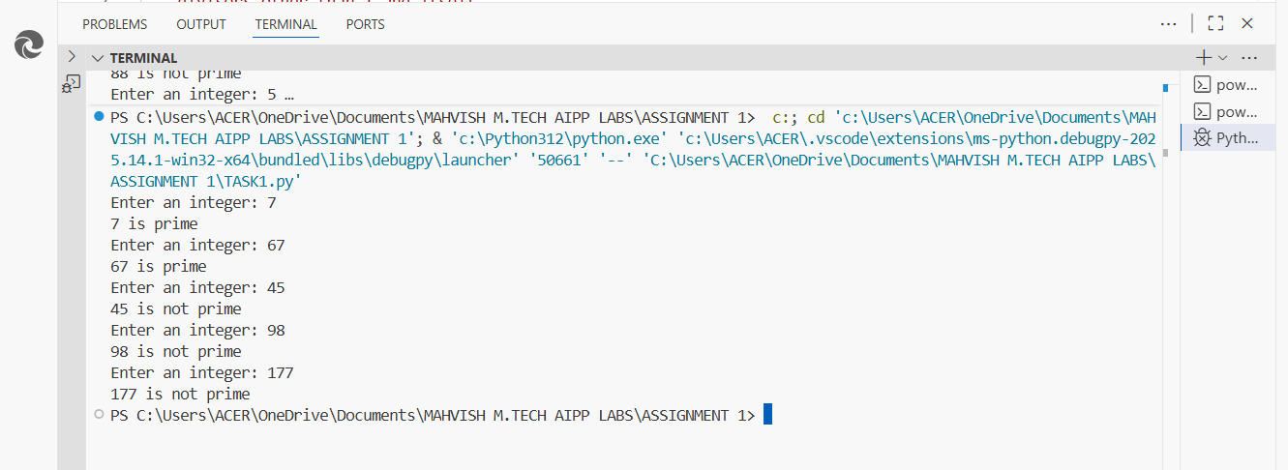

**Task 3:**

**Write a comment to REVERSE A STRING and use Copilot to generate the function.**

***PROMPTS:***

**1) Generate the function to REVERSE A STRING.**

**2) Automatically reverse the string without User Input.**

***CODE:***

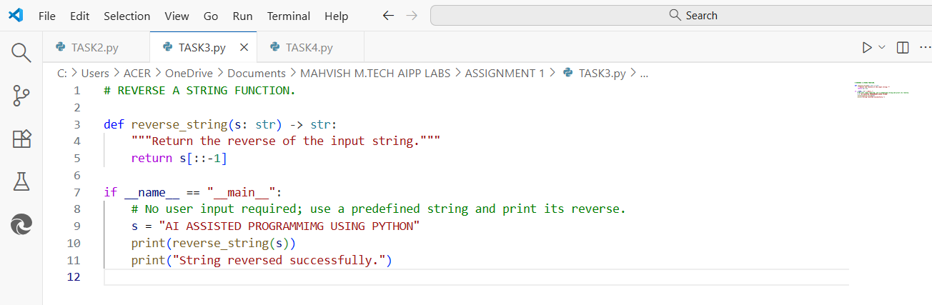

***OUTPUT:***

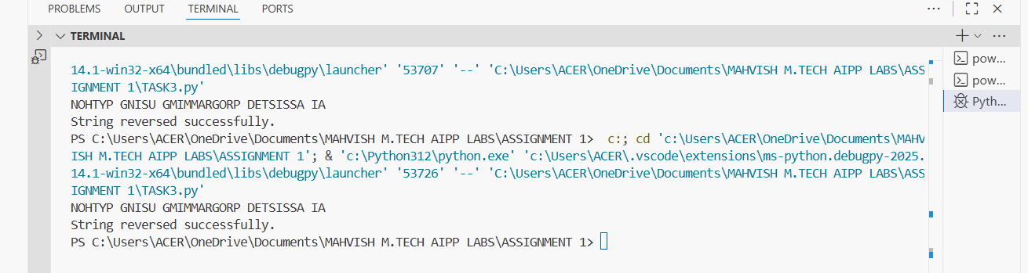

**Task 4:**

**Generate both recursive and iterative versions of a FACTORIAL FUNCTION using comments.**

***PROMPTS:***

**1) Give Factorial Function Program**

**2) Update the code for both Recursive and Iterative functions.**

**3) I need to enter at least 2 numbers so update the code.**

***CODE:***

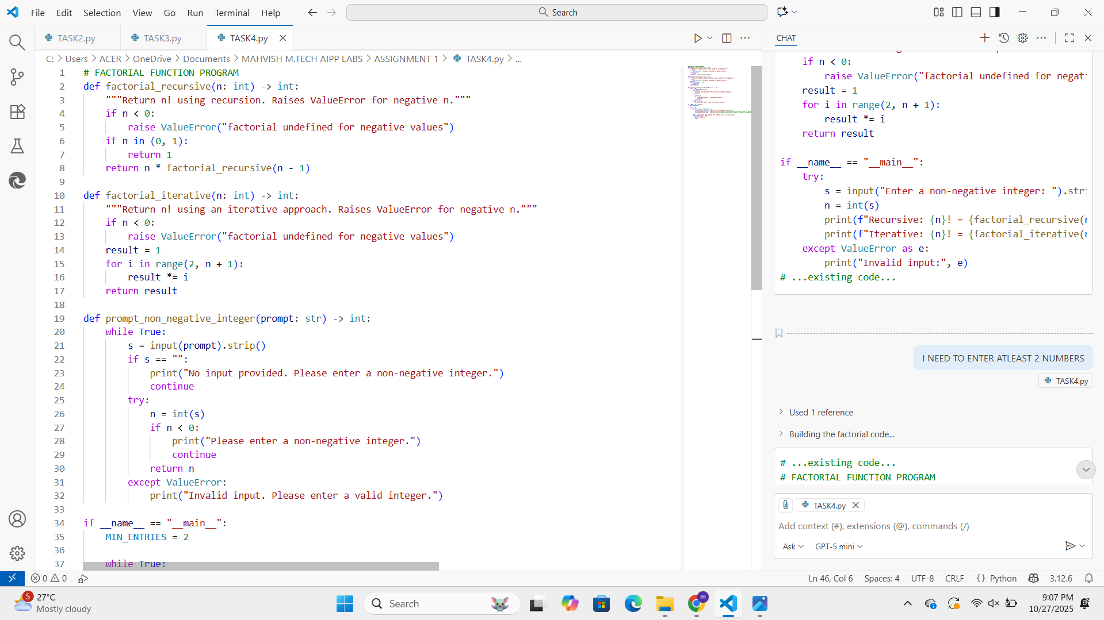

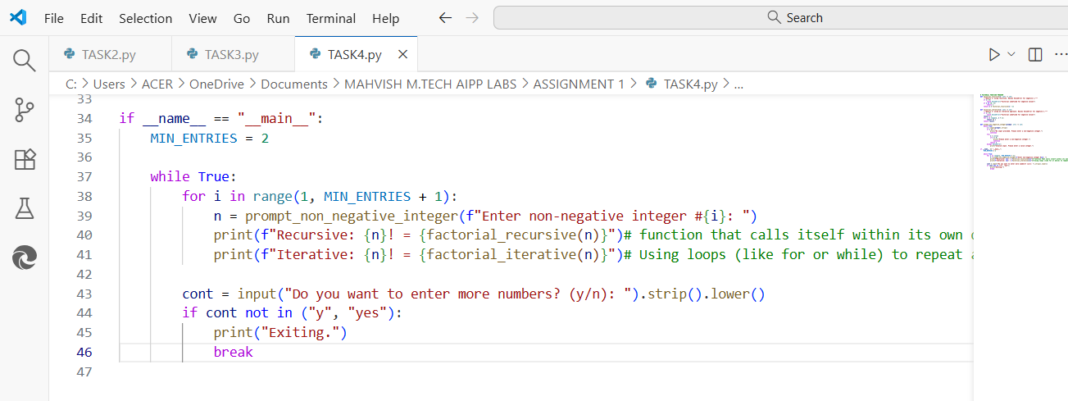

***OUTPUT:***

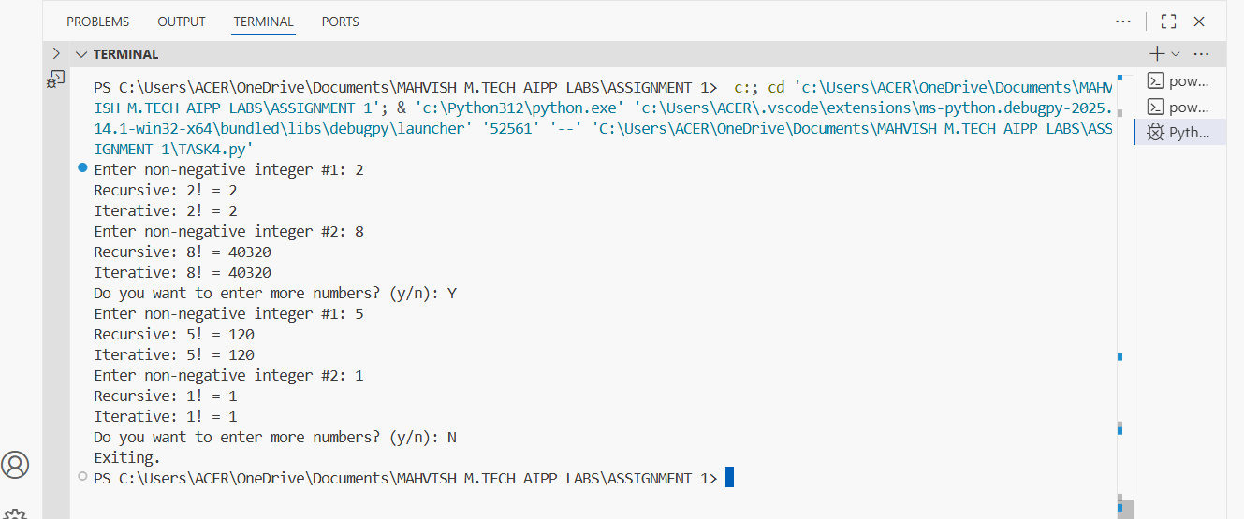

**Task 5:**

**Use Copilot to find the LARGEST NUMBER in a list. Assess code quality and efficiency.**

***PROMPTS:***

**1) Use max() function to find the Largest Number.**

***CODE:***

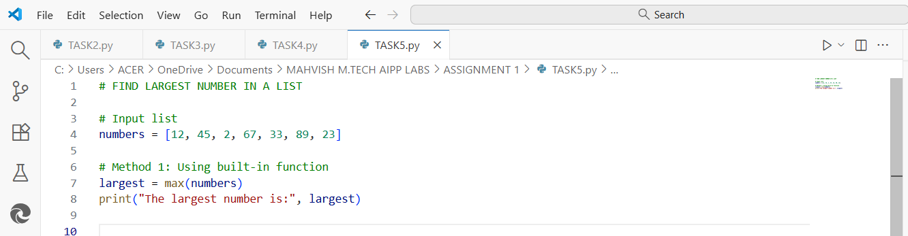

***OUTPUT:***

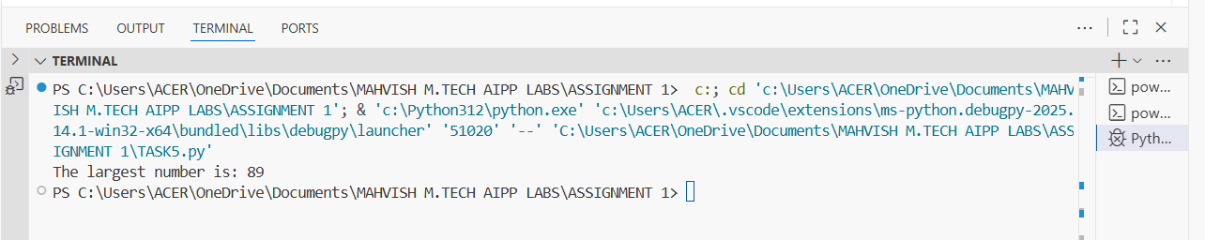

***COMMENTS:***

***# T****he function correctly returns the largest number from the given list.*

***# T****he Time complexity is O(n) which is efficient.*

***__________________________________________________________***